
2018 AUTOMOTIVE APPRENTICESHIP
INFORMATION

Company History

1934 – A company was born

February 26th, 1934, saw the launching of a fledgling new motor company in Adelaide. The objectives of which, were to specialize in the sale and service of commercial vehicles. Perhaps no more auspicious time could have been chosen to launch a new motor company than during the great depression, and even more, a company which intended limiting itself to specializing in the sale and service of trucks.

In late 1945 and 1946, when new vehicles were still in extremely short supply, the purchase of a considerable number of war disposal trucks in the Northern Territory kept the doors open until supplies of Commer trucks from the UK and Diamond Ts from the USA recommenced and shipments of Case tractors increased.

For a vehicle starved population the Company was, during the late '40s and early '50s, able to sell virtually every new truck and tractor it could obtain. It was thus a period of considerable growth.

In the early 1960’s the long association with Diamond T trucks and Case tractors regretfully came to an end following changes in the operations and ownership of both companies in America.

From 1954 until 1966 the Company distributed Humber and Hillman cars in South Australia alongside Commer, all products of the then Rootes Group of Great Britain.
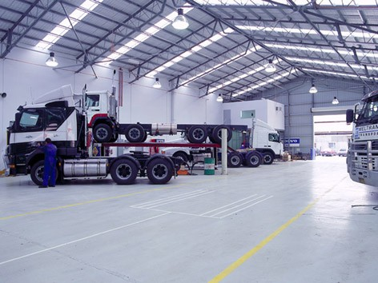
Figure 1 Clayton Dealership

In September 1988, negotiations were concluded with Volvo Australia to take over the factory run Volvo Truck Dealership at Campbellfield in northern Melbourne. This business now operates as CMV Truck & Bus Pty. Ltd. A further outlet for this business at Clayton in south-east Melbourne was acquired in 1993 from Volvo Australia.

Further developments took place in Victoria during 1999, with the Volvo Dealership at Clayton moving to purpose built premises to better serve the customer base of that area.
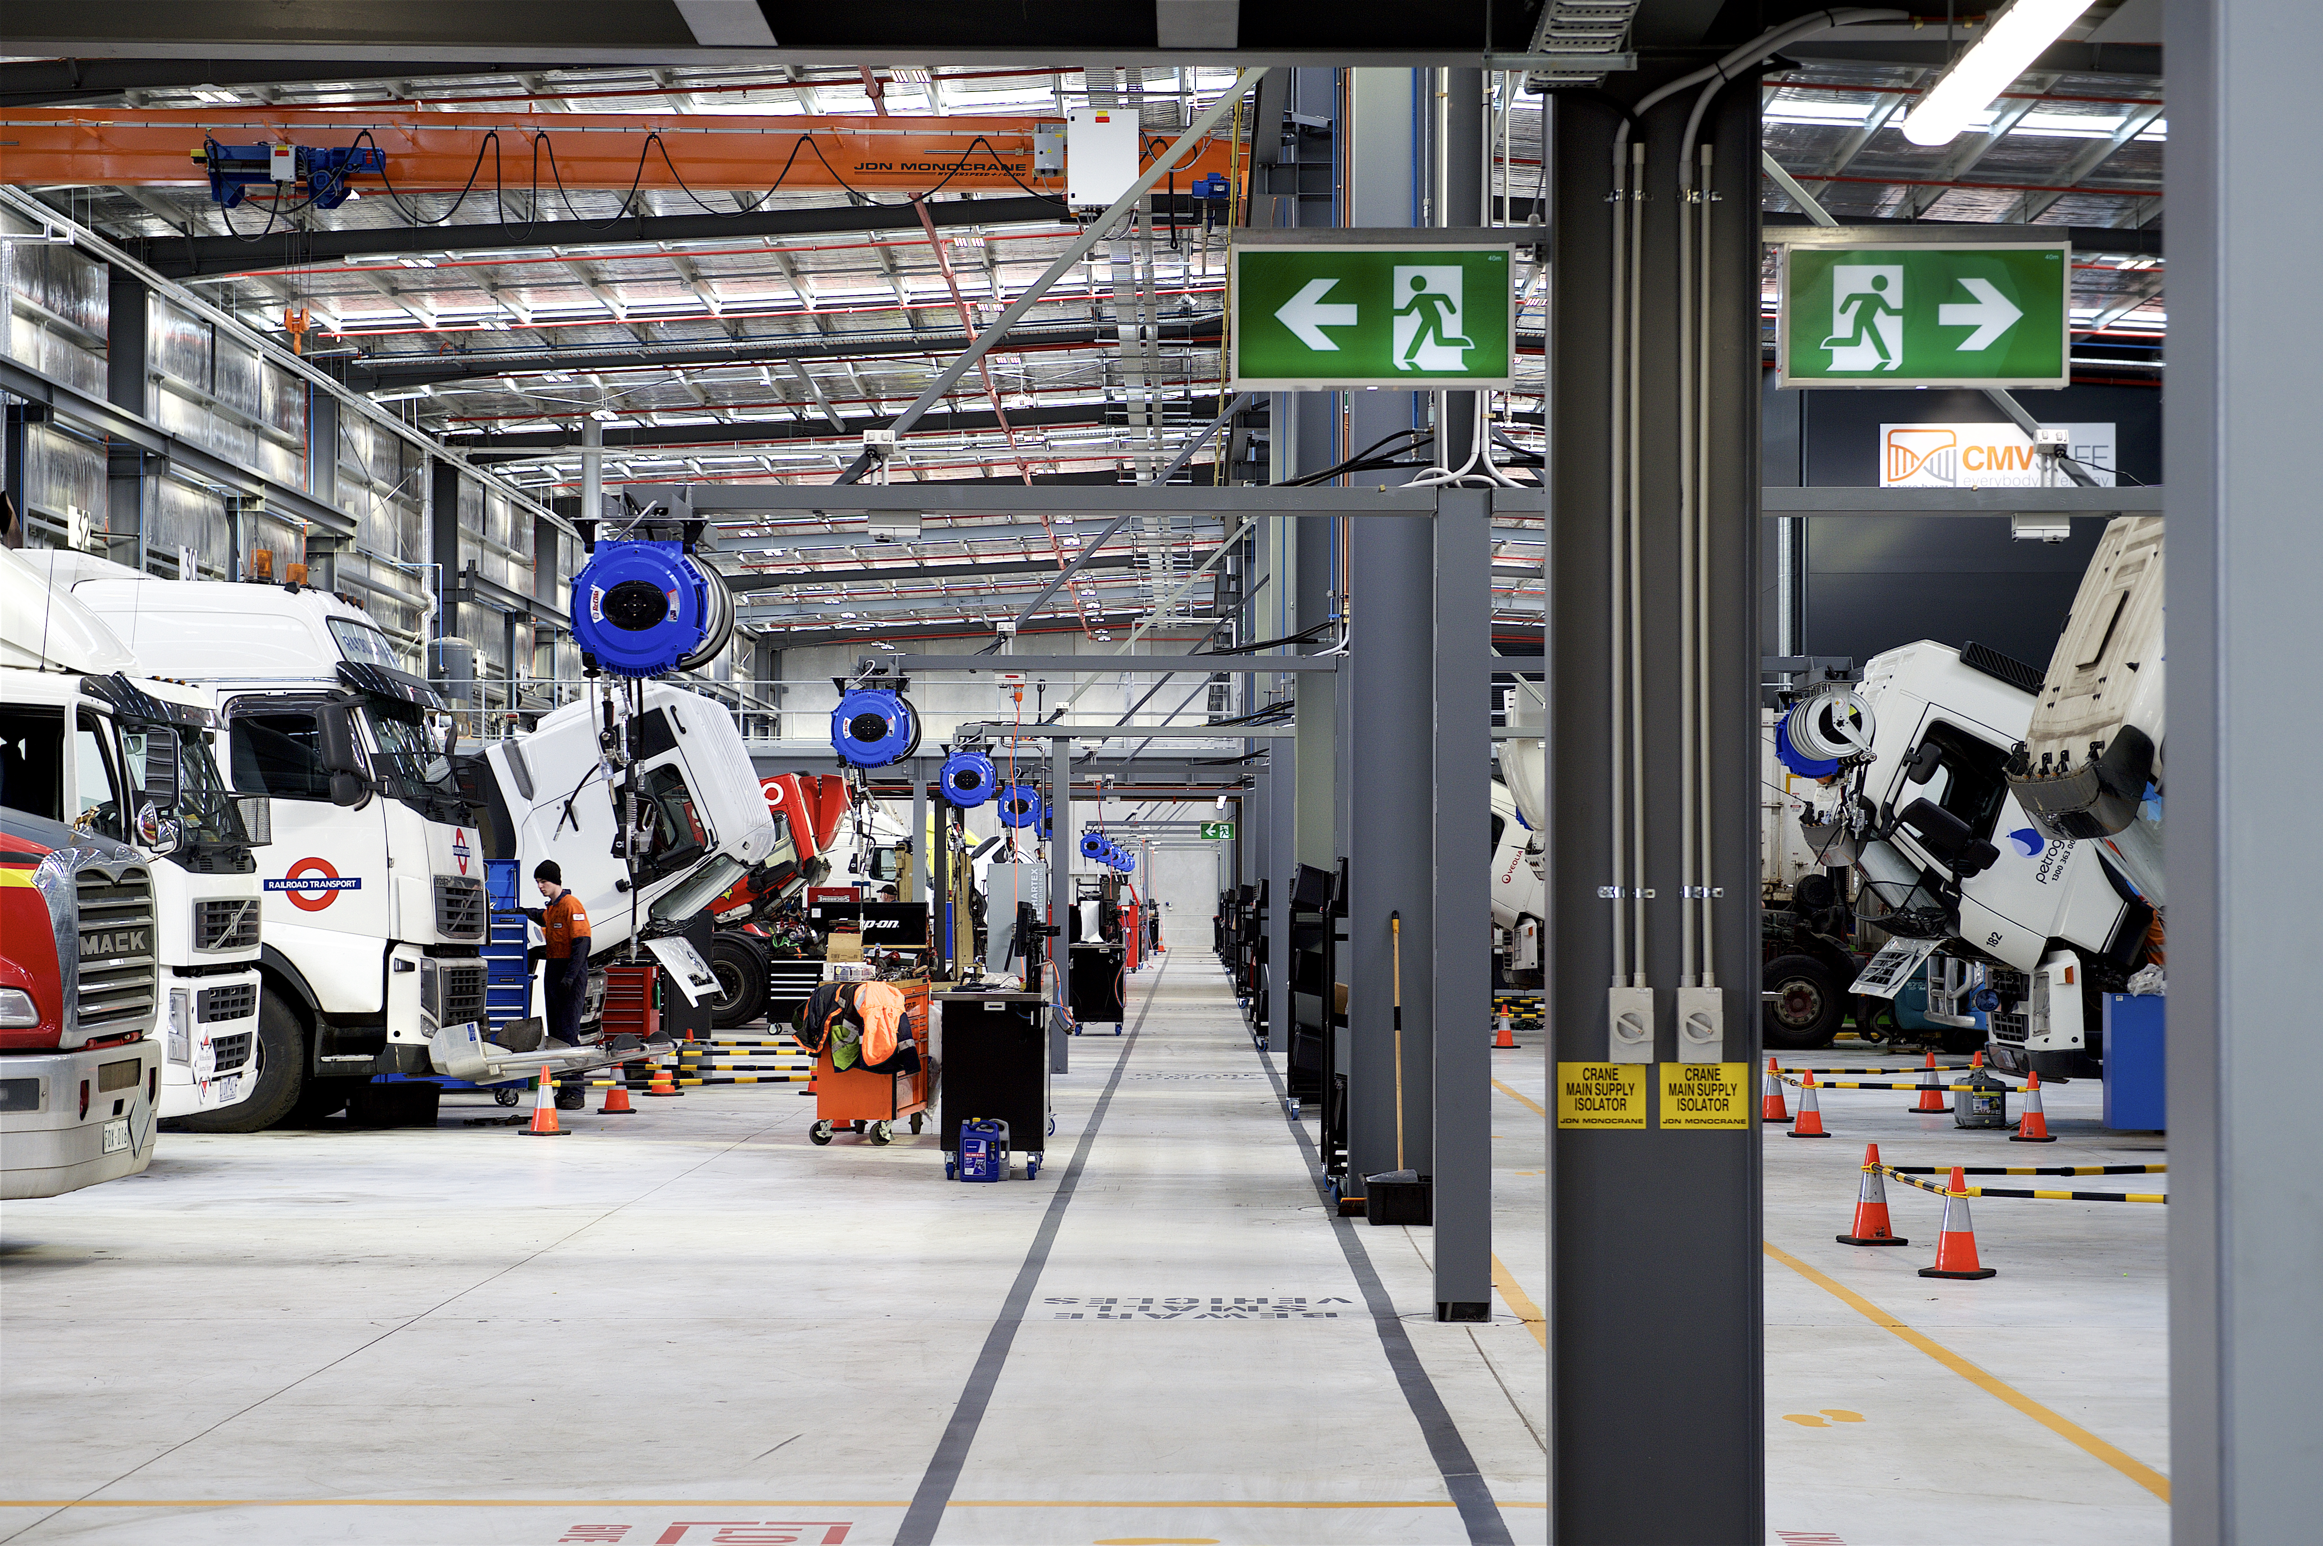
A Greenfields site at Laverton in Victoria was acquired by CMV in 1999 for the construction of a dual-franchised Dealership for Volvo and
Hino trucks and buses. This Dealership commenced operation in January 2000 when CMV Truck & Bus at Campbellfield relocated.

2003 our Fast Track Apprentice scheme began, with a state of the art training facility built close to our Laverton based Dealership.
Figure 2 Derrimut Dealership
December 2005, the CMV Gippsland Dealership was added to CMV Truck & Bus. This Dealership moved to Traralgon in December 2007. It is now a dual franchised Dealership with the Mack and Volvo product.

From May 15, 2006, CMV Group entered into franchise agreements with Mack Trucks to take over the Factory run Mack Truck Dealership at Laverton and Dandenong. The agreements also allow dual branded Dealerships to sell Mack and Volvo Trucks at Traralgon, Clayton and Dandenong

In June 2009 UD Trucks were introduced to CMV Mack Laverton, Dandenong and Traralgon dealerships. UD Trucks have an excellent offering in the medium and heavy duty range and is, as always, a very reliable workhorse for many tipper and prime mover applications. This is an exciting opportunity for us to see CMV and UD Trucks grow into the future.

On October 4, 2010, CMV Truck and Bus Pty. Ltd. was allocated the Mack and Volvo Dealership in Albury. In addition to these franchises, CMV was awarded the UD Trucks franchise in November 2010. In May 2012, CMV opened a brand new state of the art facility in McKoy Street, Wodonga, to make it easier for customers to access and give CMV the ability to provide first class customer Service in the Albury/Wodonga area.

The CMV Group today

From a staff of five in 1934, the successful CMV Group now operates substantial operations in South Australia and Victoria with over 1,000 employees and an annual turnover in excess of $1,090,000,000.

Apprenticeship Details
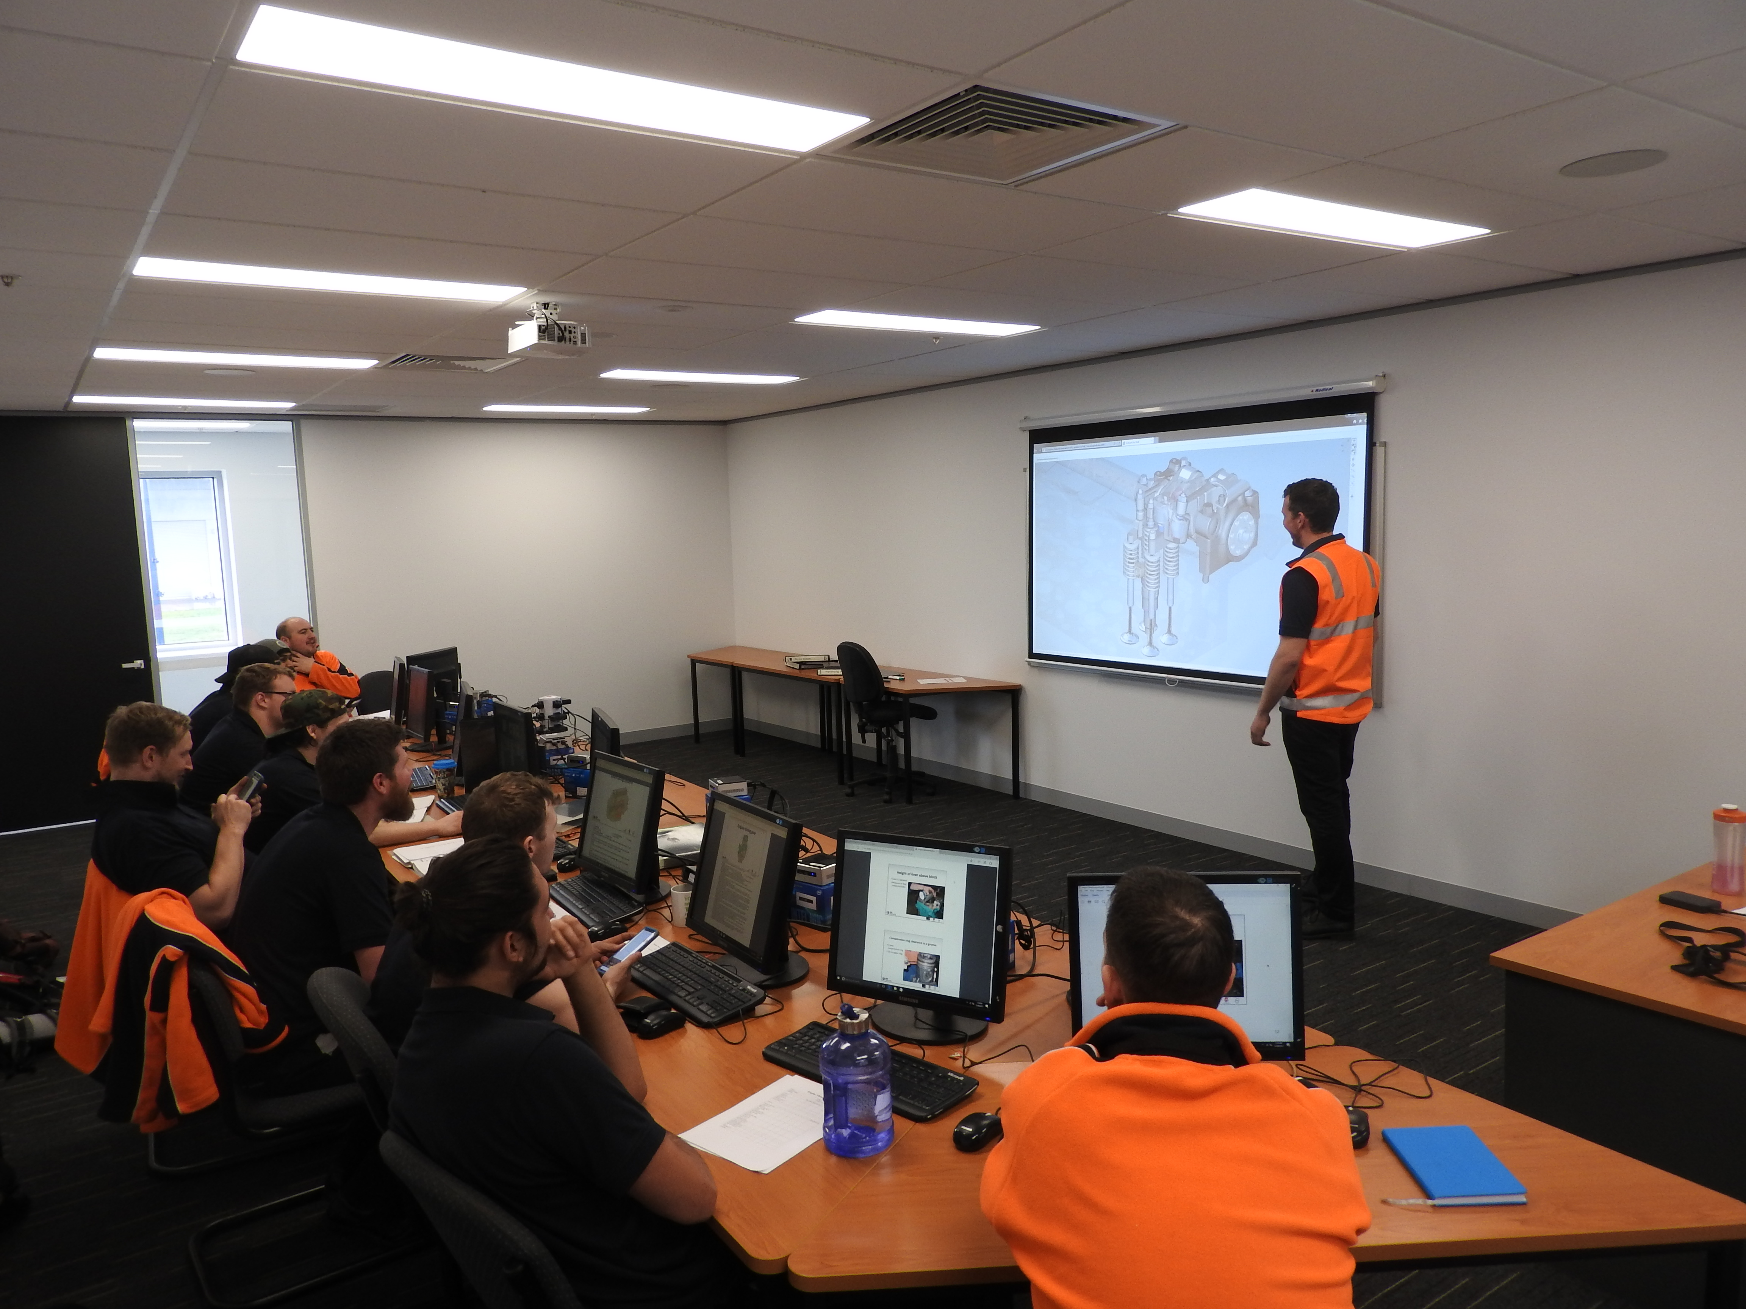
CMV is now seeking twenty three (23) ambitious, disciplined results focused individuals who are enthusiastic about accelerating their career in an exciting automotive profession with an outstanding product to commence their Apprenticeship in 2018.
Figure 3 Training Centre

We have six fully equipped major workshops and a state-of-the-art Technical Training Centre (CTTC). All successful applicants will undergo their theoretical training at the CTTC. This training will be overseen by four experienced heavy stream automotive Technical Trainers, with additional inputs from a highly regarded Registered Training Organization (Kangan institute of TAFE). The on-the-job elements of their training will occur at one of our major workshops. This is a very thorough training process involving many assessments along the way.

The addresses of these facilities are:-

CTTC: 392 Boundary Road, Derrimut, 3030

Derrimut Mack/UD/Volvo Workshop: 392 Boundary Road, Derrimut, 3030

Laverton Hino: 326 Boundary Road, Laverton North, 3026

Clayton Mack/UD/Volvo Workshop: 1683 Centre Road, Springvale, 3171

Dandenong Mack/UD/Volvo Workshop: 77 – 79 Princes Highway, Dandenong, 3175

Traralgon Mack/UD/Volvo Workshop: 17 – 23 Standing Drive, Traralgon, 3844

Albury Mack/UD/Volvo Workshop: 221 McKoy Street, Wodonga, Vic. 3690

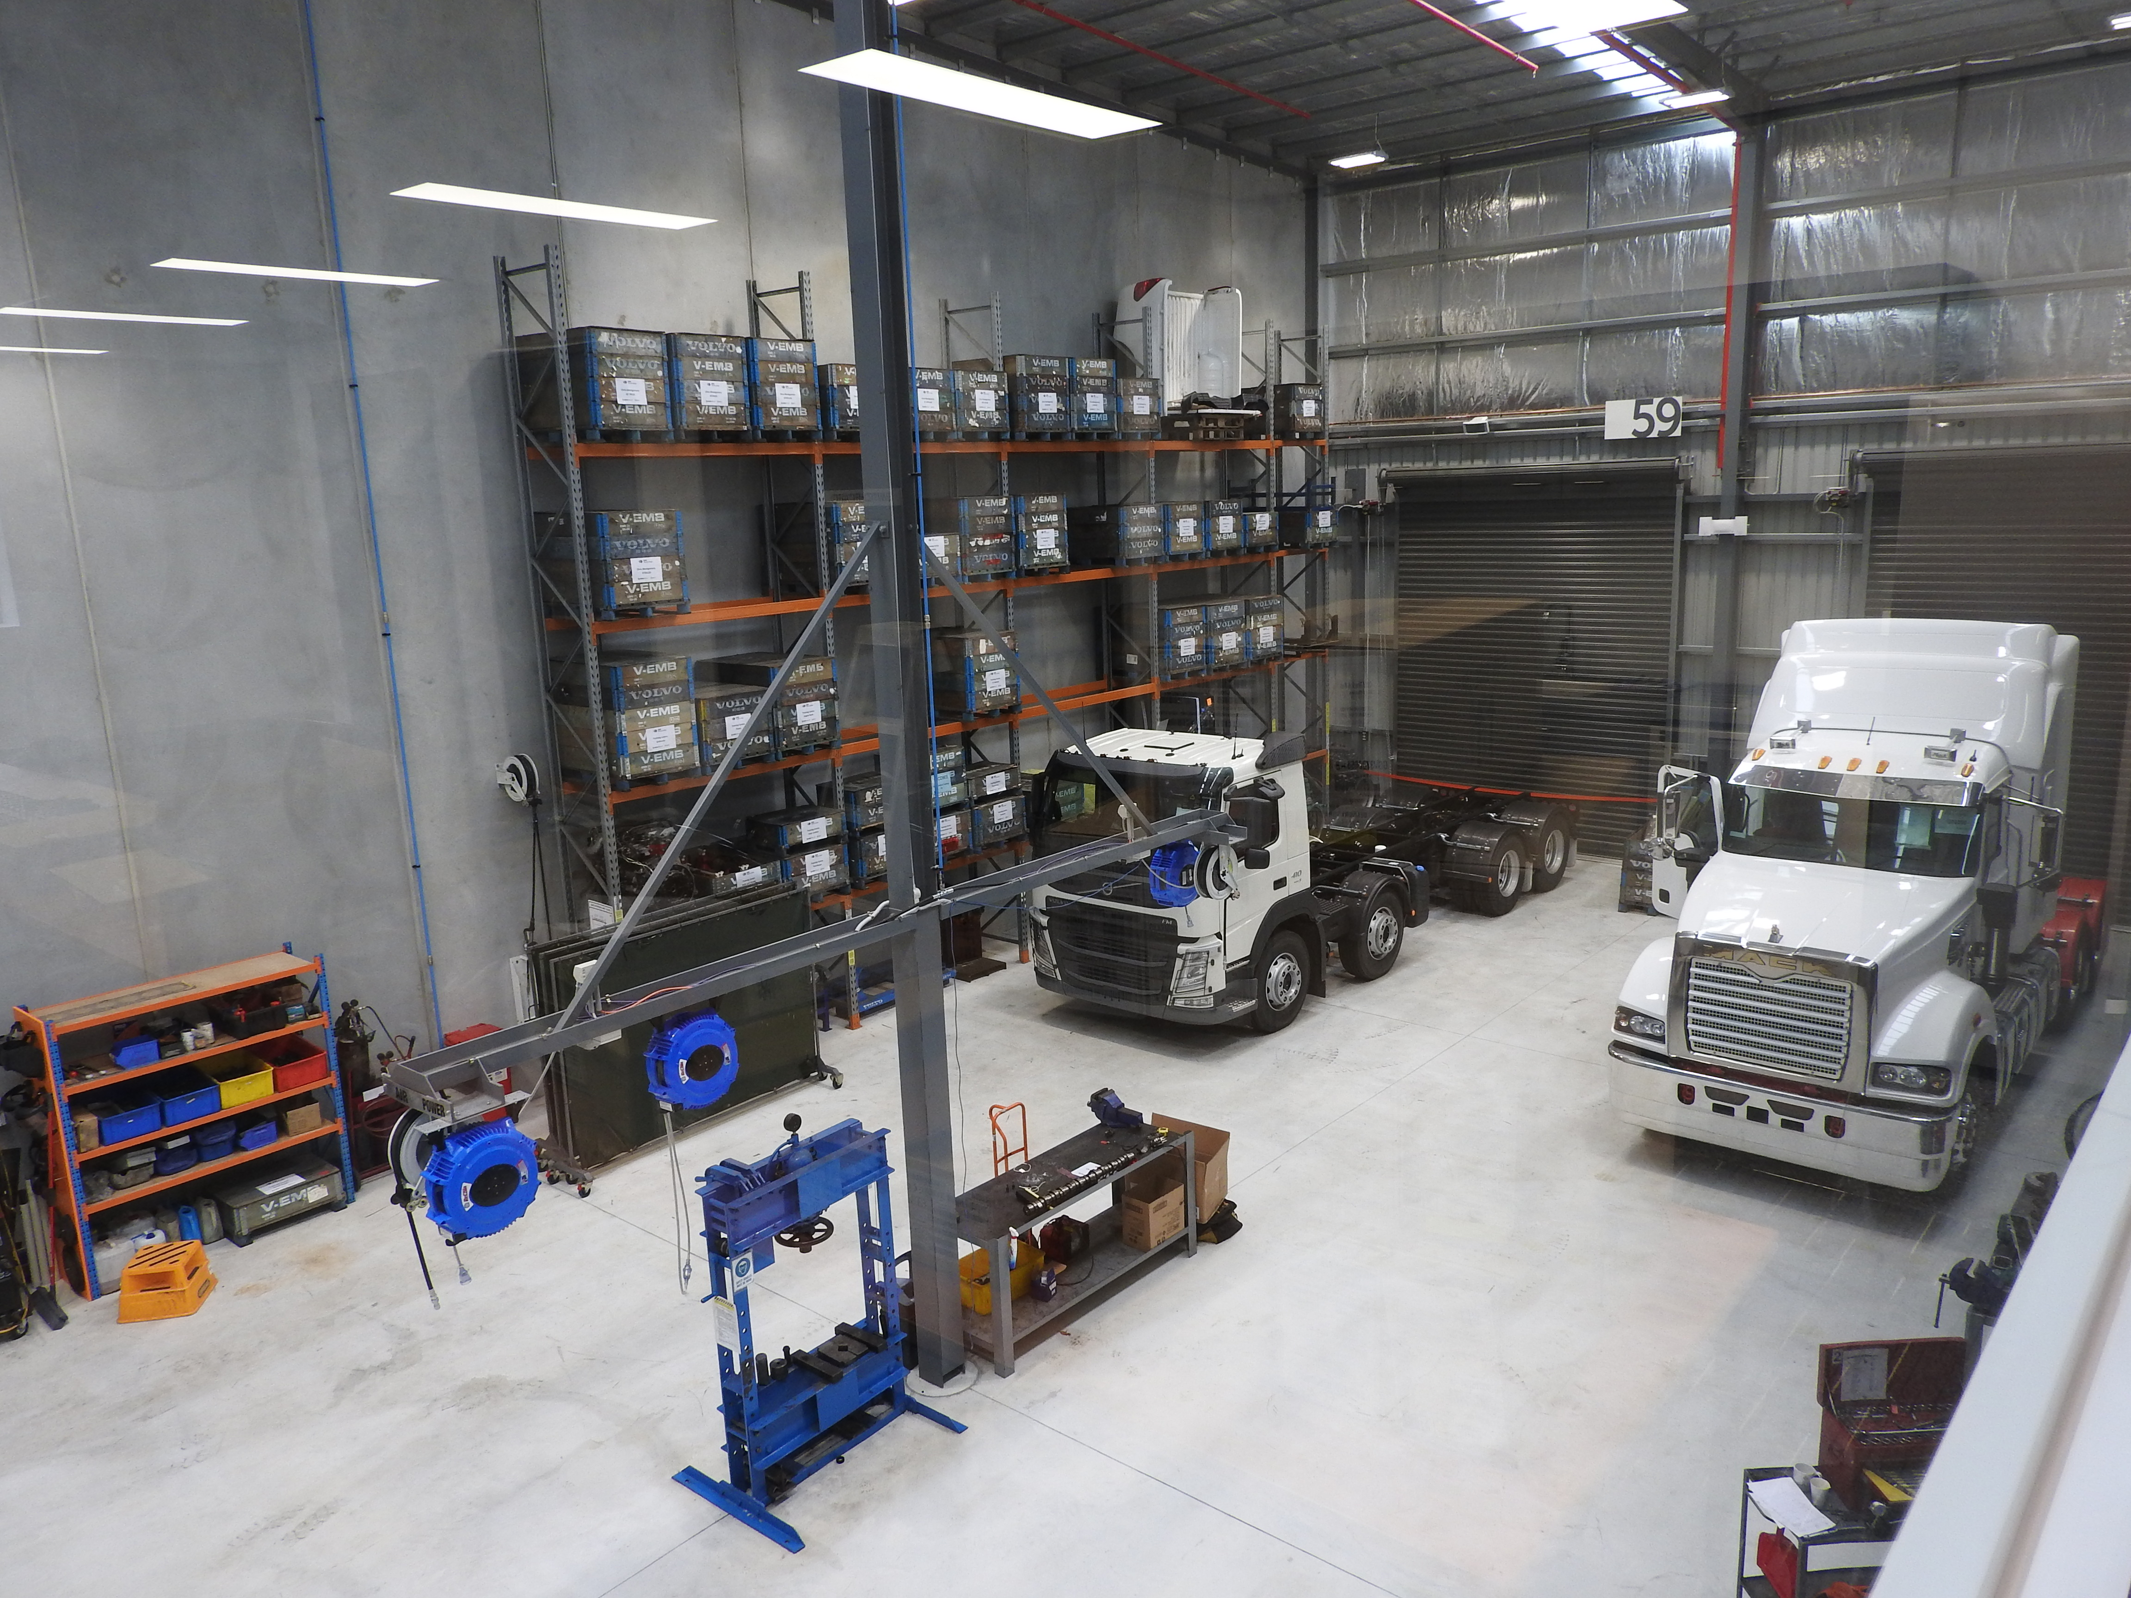
Feel free to nominate your preferred workshop in your application.
Figure 4 Training Centre Workshop

Traditionally, such an Apprenticeship can extend over a period of up to four (4) years, depending on the achievement of the required competencies. However, we envisage that with the close guidance of the Training Manager and subsequent fast tracking of the Apprenticeship, the necessary skill and competency requirements can be met to achieve full qualifications in three years. Currently with overtime, our fully qualified Technicians earn between $55,000 - $75,000 per annum.

CMV Technical Training Centre

The CMV Technical Training Centre moved to its new site in Derrimut in August 2017. We have state of the art facilities and equipment which also incorporates four training rooms. Our four dedicated Trainers work with apprentices, technicians and assist with any staff training. The well-appointed workshop has most of the same tools the dealership uses, helping the trainee to safely understand the safe and proper use of the tools they will be utilizing daily. Since its beginning, the Training Centre has supported the growth of several apprentices through their apprenticeship to graduation and into technicians, with some moving up through the company to become Managers.

Job Description

Automotive Technicians will primarily service and repair the mechanical parts of heavy motor vehicles such as the engine, transmission (clutch, gearbox and differential) and the suspension systems (springs, steering, brakes, wheels and tyres). They will perform tasks including discussing problems with truck drivers to discover faults and carry out their own diagnosis procedures. They will also repair and service cooling systems, fuel systems, air conditioning, clutch assemblies, manual and automatic transmissions, braking systems, final drive assemblies and steering and suspension systems. The repair of electronic, drive management, suspension, engine, brake and other electronic systems are also encompassed in the Automotive Technician’s duties. With the rapid changes in automotive technology, Automotive Technicians are becoming more specialized in their areas of work.

With Volvo Trucks all components, with few exceptions, are manufactured by Volvo. This means we need to train you to repair anything from the in-built phone to the engine.

Competency Standards relating to:-

Certificate III in Heavy Commercial Vehicle Mechanical Technology
National Code: AUR31116

Year 1
AURAEA002 Follow environmental and sustainability best practise in an Automotive workplace
AURAEA003 Monitor and sustainability best practice in the automotive mechanical industry
AURETR012 Test and repair basic electrical circuits
AURETR025 Test, charge and replace batteries
AURTQ001 Service final drive assemblies
AURTTE004 Inspect and service engines
AURTTC003 Diagnose and repair cooling systems
AURTTF002 Service diesel fuel injection systems
AURTTA004 Carry out servicing operations
AURTTK002 Use and maintain workshop tools and equipment
AURTTD002 Inspect and service steering systems
AURTTD004 Inspect and service suspension systems
AURVTW003 Carry out gas metal arc welding procedures
AURVTW008 Carry out acetylene welding, thermal cutting and thermal heating procedures

Year 2
AURTTA006 Service hydraulic systems
AURHTZ001 Diagnose and repair heavy vehicle emission control systems
AURTTF004 Repair diesel fuel injection systems
AURHTE002 Repair engine and associated engine components
AURHTQ002 Repair final drive assemblies
AURHTQ003 Repair final drive - driveline
AURHTD002 Repair steering systems
AURHTD003 Repair suspension systems
AURTTB004 Inspect and service air brakes
AURETR029 Diagnose and repair charging systems
AURETR030 Diagnose and repair starting systems

Year 3
AURHTX004 Diagnose and repair heavy vehicle clutch systems
AURETR022 Diagnose and repair heavy vehicle dynamic control systems
AURETR024 Diagnose and repair electronic compression ignition engine management systems
AURTTA018 Carry out diagnose procedures
AURHTB001 Repair air braking systems
AURHTX003 Repair transmission (Automatic)
AURHTX001 Repair transmission (Manual)
AURTTF005 Inspect and repair engine forced induction systems
AURETU003 Service air conditioning and HVAC systems
AURETU005 Retrofit and modify air conditioning and HVAC systems
AURETU004 Diagnose and repair air conditioning and HVAC systems

Course Requirements

To be awarded the qualification, the New Apprentice must attain a successful assessment of all four (4) compulsory core Competency Standards, all of the listed Stream Competency Standards, plus all 19 electives.

Career Opportunities

Gone are the days in the automotive industry when the only thing mechanics handled was oil and grease! Be a Technician, not just a mechanic! Today’s highly sophisticated automotive environment comprises skilled Technicians working with advanced machinery and computers on sophisticated motor vehicles. If you are interested in the fast-moving automotive industry and are seeking more than a trade, this special “fast-track” Mack/UD/Volvo Apprenticeship is an opportunity to get a career, not just a job!

On successful completion of the Mack/UD/Volvo Apprenticeship the twenty three (23) highly skilled Mack/UD/Volvo Technicians, who will be greatly conversant with Mack/UD/Volvo procedures, will be enticed to begin a long term career with the diverse CMV Group Mack/UD/Volvo Truck Dealerships, where the benefits of career opportunities within the broader environment are endless. Successful graduates will also have the opportunity to go on to do further training and become more qualified within their profession.

Successful Applicant Qualities

We want to hear from you if you are an ambitious, disciplined, result focused individual who is enthusiastic about accelerating their career in an exciting automotive profession. While motor vehicle knowledge would be highly regarded, it is not essential. We are seeking twenty three (23) highly motivated individuals who have a strong work ethic and passion for an exciting career in the automotive industry.

Application Procedure

To obtain an Application Form please phone (03) 9931 6000. Alternatively, you can download the Application Form by going into our website, www.cmvtb.com.au, click on the Careers section at the top right hand corner, then under the section CMV Truck & Bus Automotive Apprenticeship Scheme, click on the Application Form. The completed form then needs to be sent to:

Mrs. Lesley Wickham
Secretary to the Senior General Manager
CMV Truck and Bus Pty. Ltd.
392 Boundary Road
DERRIMUT, Vic. 3030

Or

lwickham@cmv.com.au

